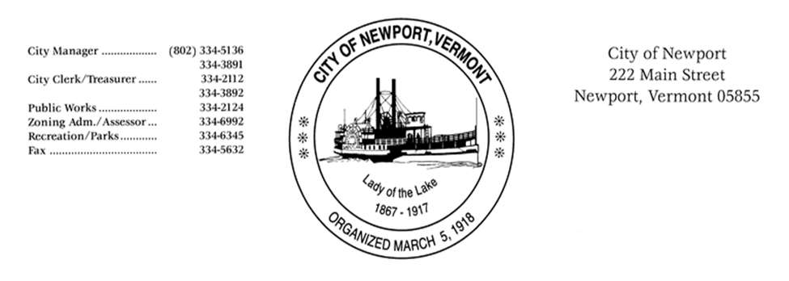

NEWPORT CITY DEVELOPMENT REVIEW BOARD
NOTICE OF PUBLIC MEETING

Wednesday February 10, 2021 at 7:00 PM

Due to COVID-19 restrictions, the meeting will be held remotely.

All persons attending must participate in the meeting by
Phoning (425) 436-6395 and entering PIN: 8748673#
or by Computer by going to https://freeconferencecall.com and join the meeting by using id: erikvoegtlin

Development Review Board: John Harlamert Chair
Vacant Position
Agathe Coburn
Daniel Pickering
Jay Gonyaw
Harriet Hall Alternate

Zoning Administrator: Erik Voegtlin

Agenda:
1. Call to order.
2. Approve the minutes of the Development Review Board meeting held January 6, 2021.
3. Consider waiver request made by John Cogan on January 5, 2021 for the property of 68 Cottage Street Newport VT, 05855
- Review the Proposal
- Site Plan Review
4. Other business.
5. Adjourn

Materials regarding this meeting are available for download by 9:00 a.m. on the morning of the meeting.

Public participation is welcome and encouraged.

Posted 1/14/21

